PROJECT NAME:

HOW TO ADD GOOGLE ANALYTICS TO A WEBSITE

TEAM MEMBERS:

ABIKASH SHIVAM G; AU913120104003

ARUN KUMAR R; AU913120104304

RAJAPANDI P; AU913120104305

VISHNU KUMAR S; AU913120104308

NAAN MUDHALVAN

PROJECT

DIGITAL MARKETING

HOW TO ADD GOOGLE ANALYTICS TO A WEBSITE:

Google Analytics:

Google Analytics is a powerful web analytics tool that enables website owners to track and analyze user behavior on their sites. It provides valuable insights into visitor demographics, source of traffic, popular content, and conversion rates. With this data, you can make data-driven decisions to optimize website's performance, improve user experience, and achieve online goals.

Google Account details:

Mail Id: [automatarobotics8@gmail.com](mailto:automatarobotics8@gmail.com)

Password: a8u9t2o0m0a2ta

Website address: <https://automataroboticcs.blogspot.com/>

Google Analytics Tracking Code :

<!-- Google tag (gtag.js) -->

<script async src="https://www.googletagmanager.com/gtag/js?id=G-XBJL2TFJ12"></script>

<script>

window.dataLayer = window.dataLayer || [];

function gtag(){dataLayer.push(arguments);}

gtag('js', new Date());

gtag('config', 'G-XBJL2TFJ12');

</script>

Google Analytics Account Setup:

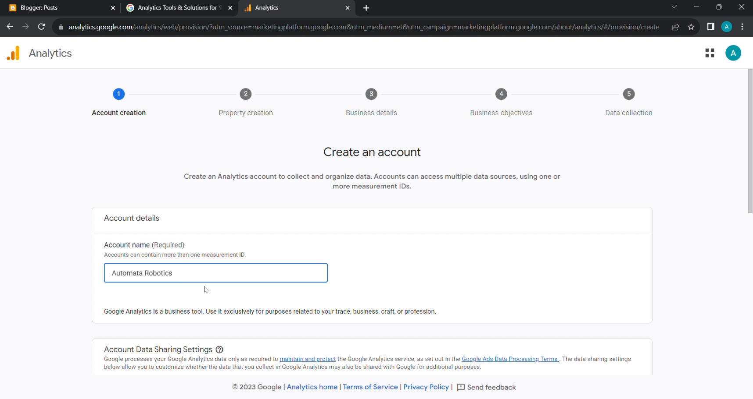

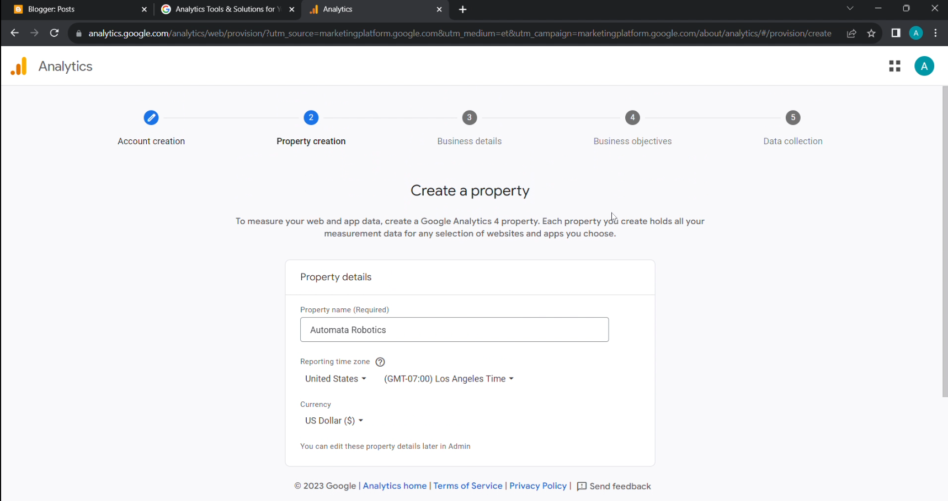

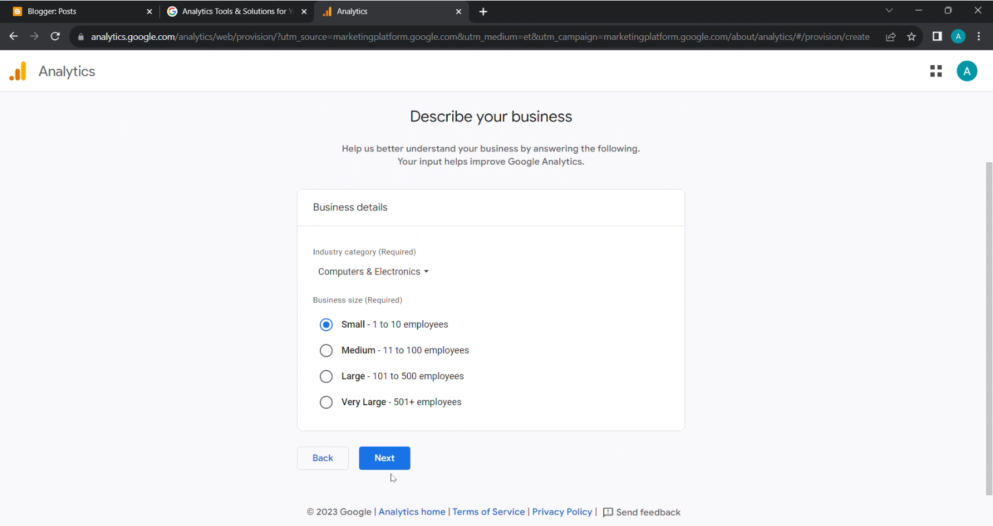

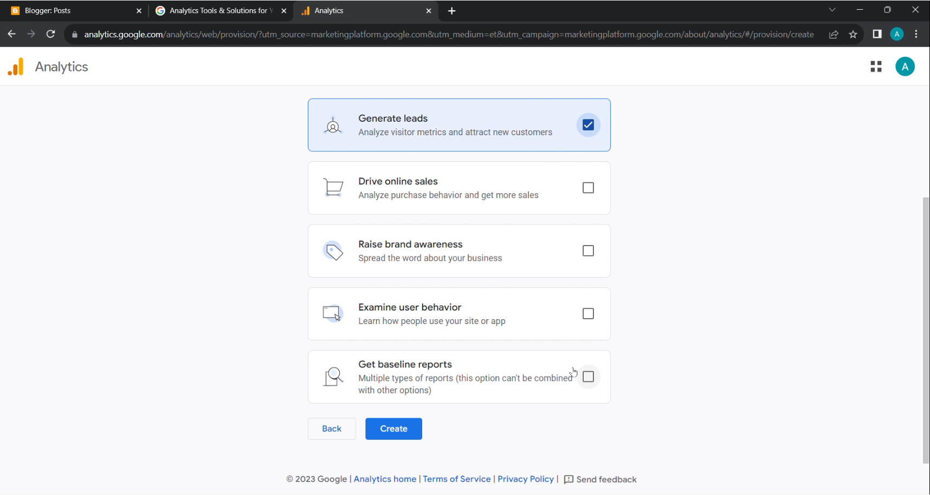

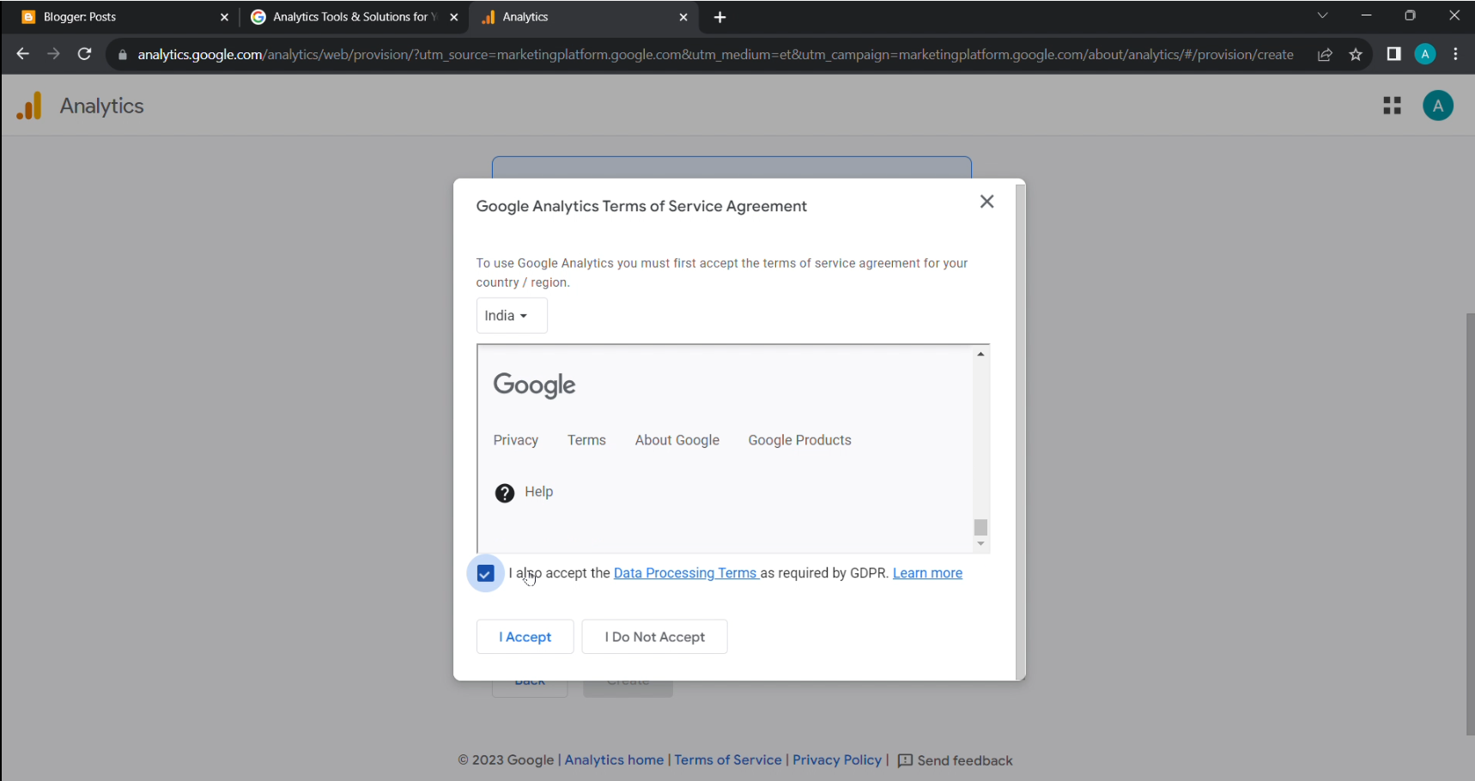

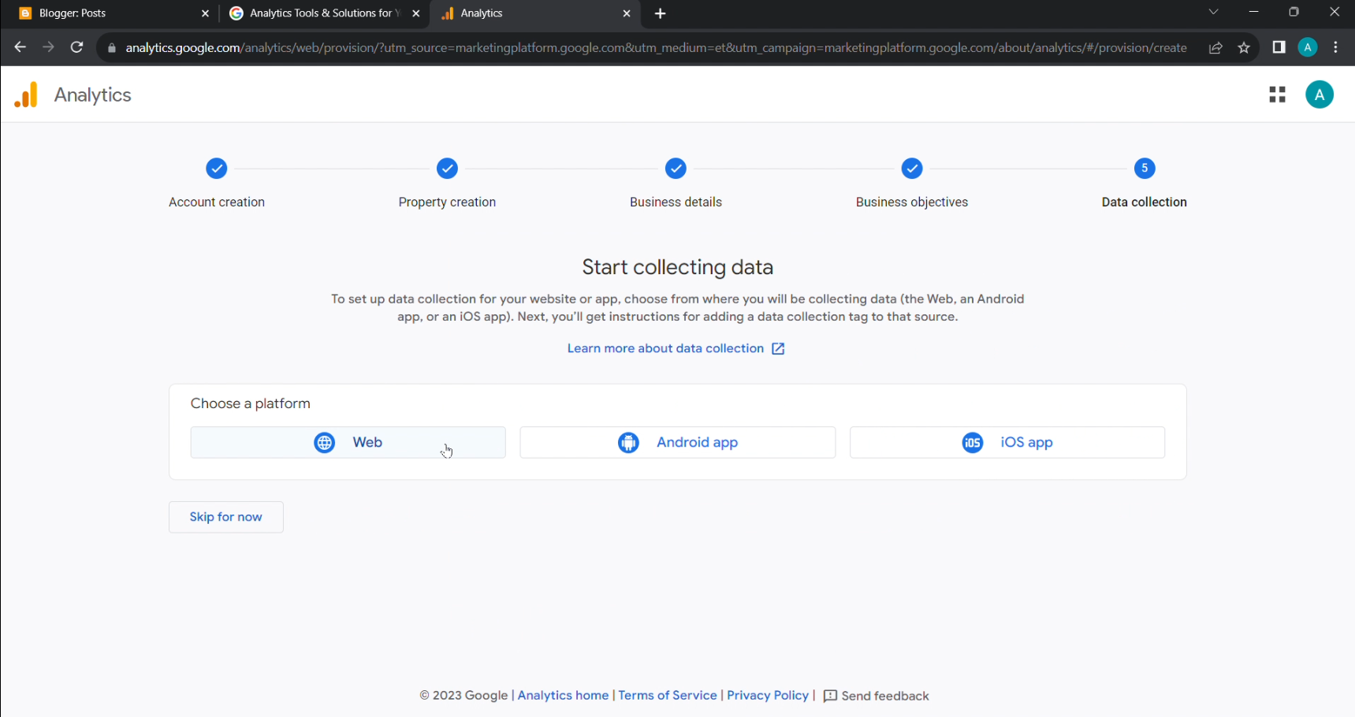

How to link the google analytics to website:

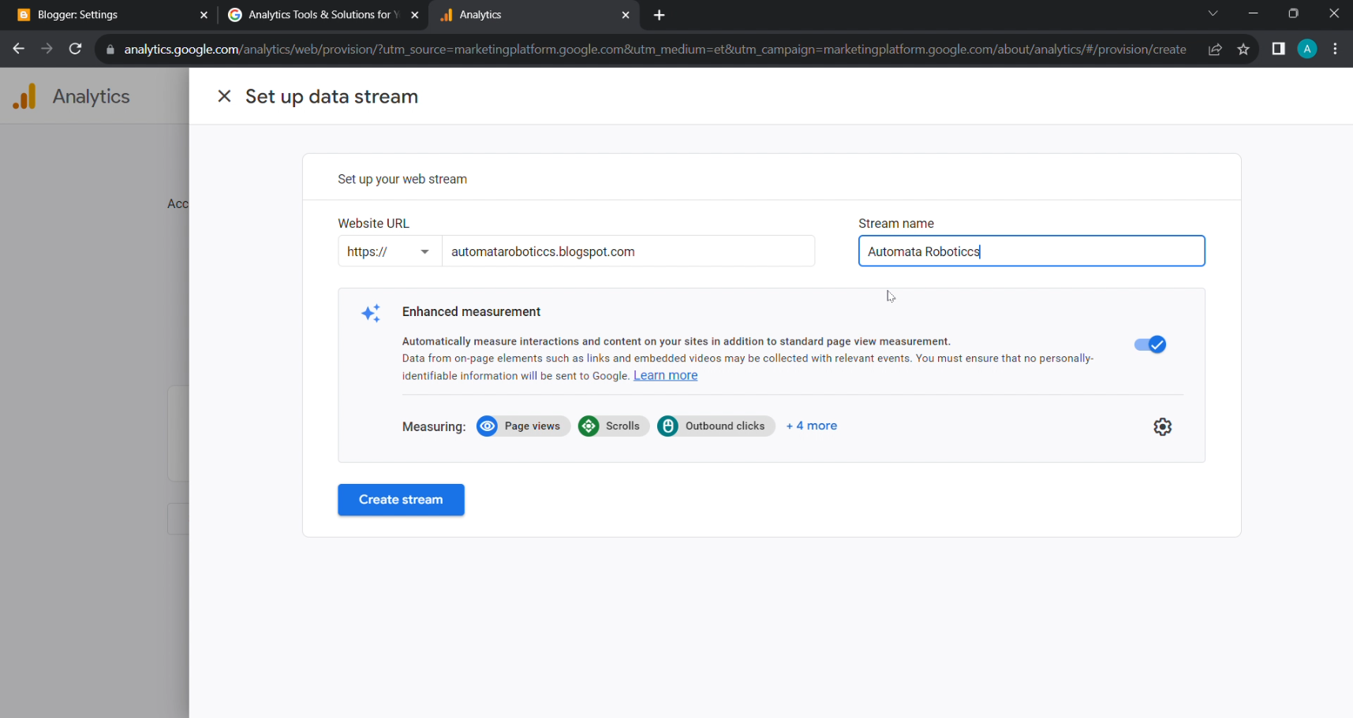

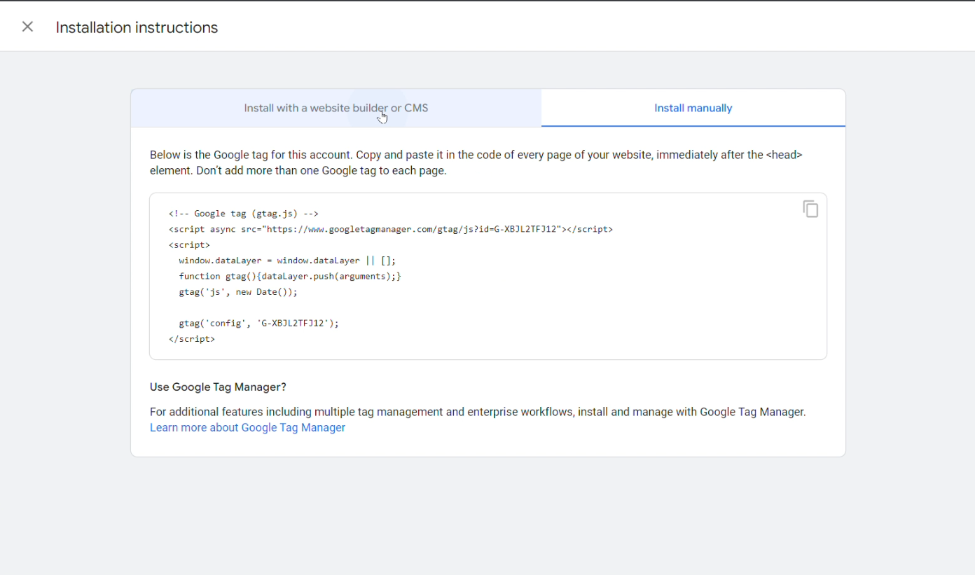

* Adding the google measurement id to the website .

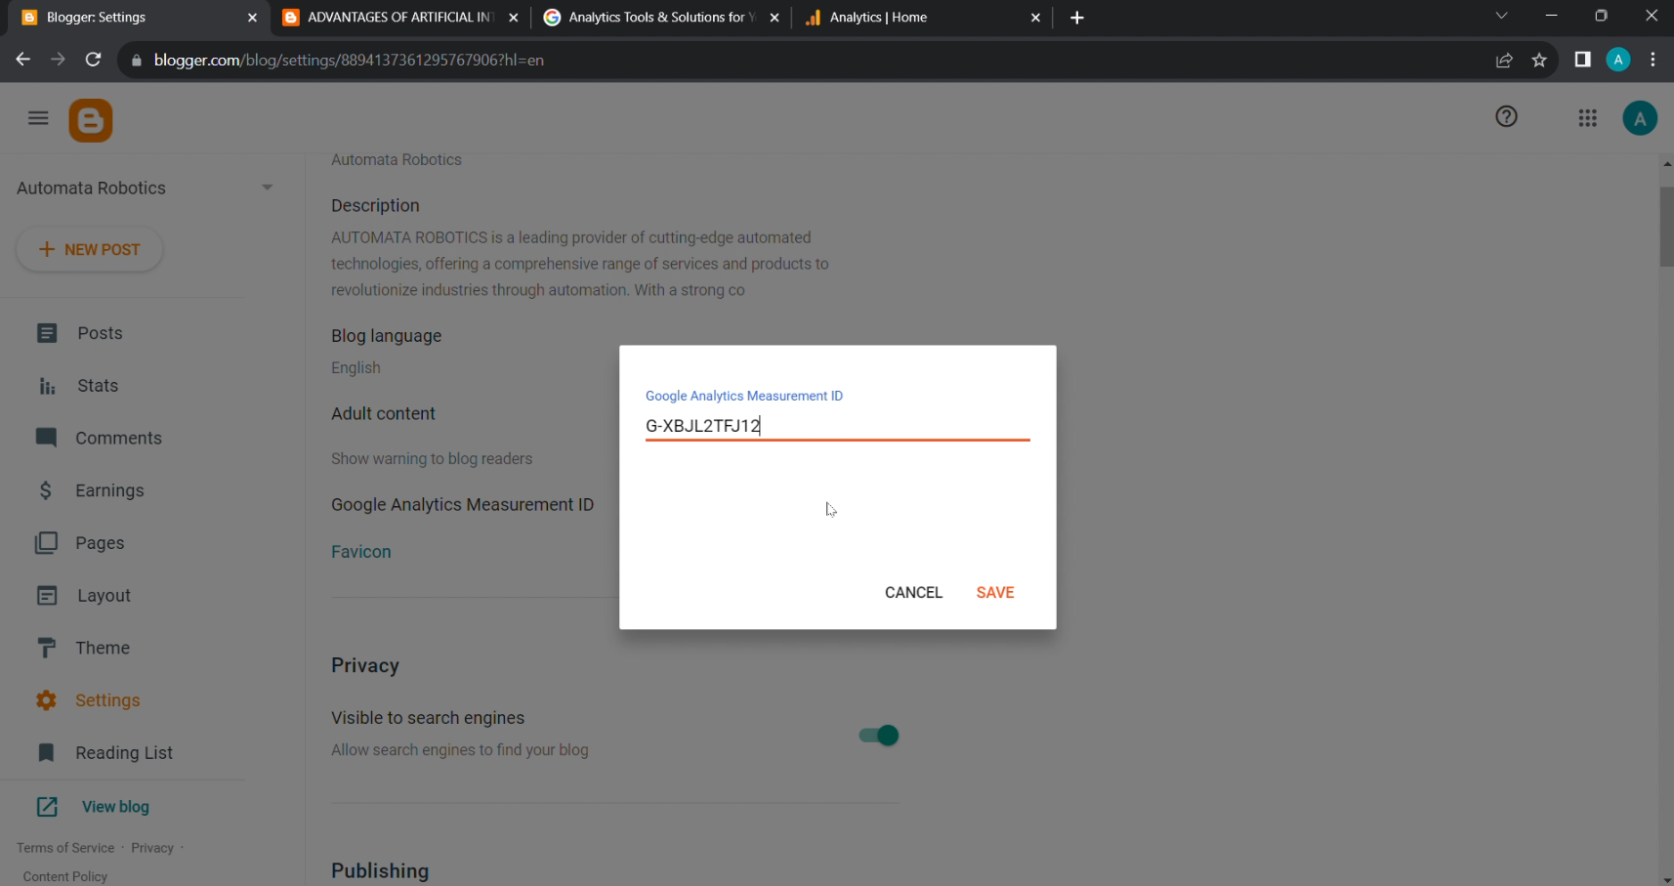

* The google measurement id is placed in the html page of the website .

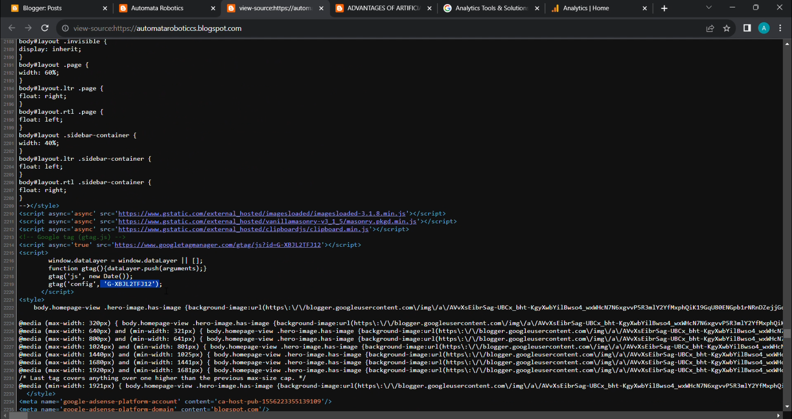

* The data collection is successfully started .

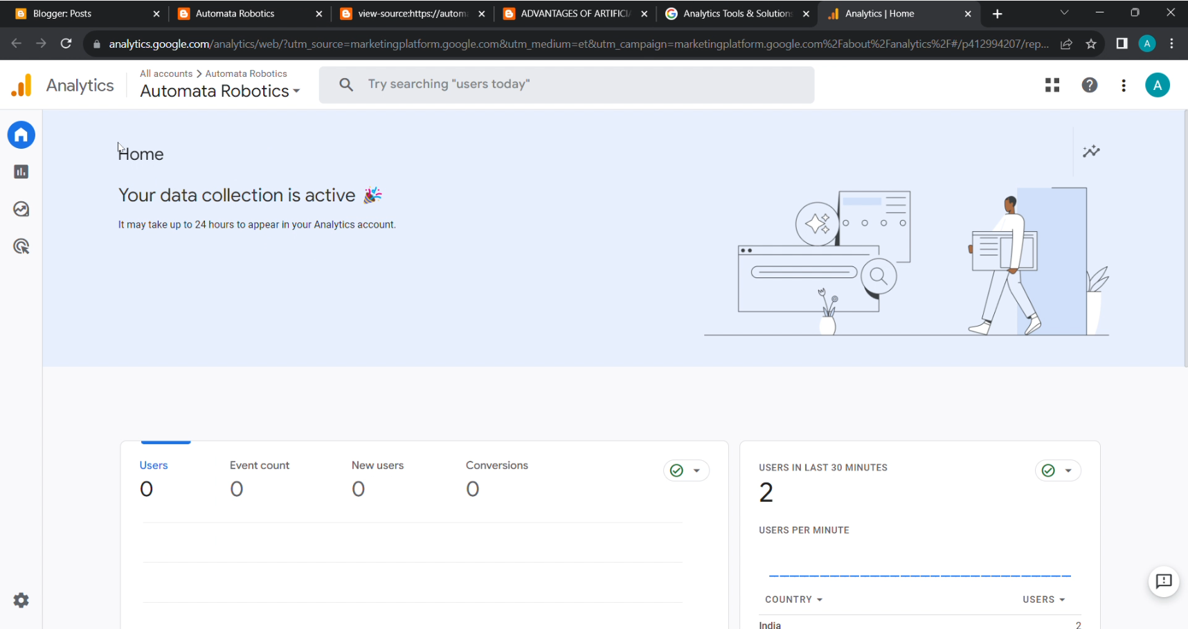

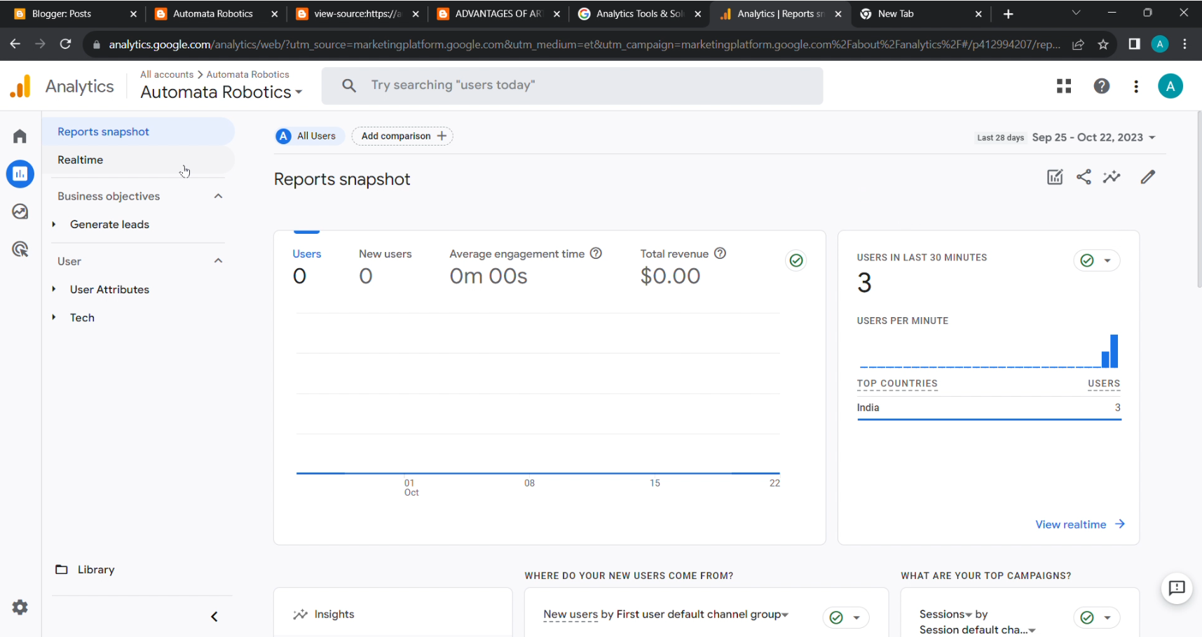

* This page gives several information about the website’s usage .

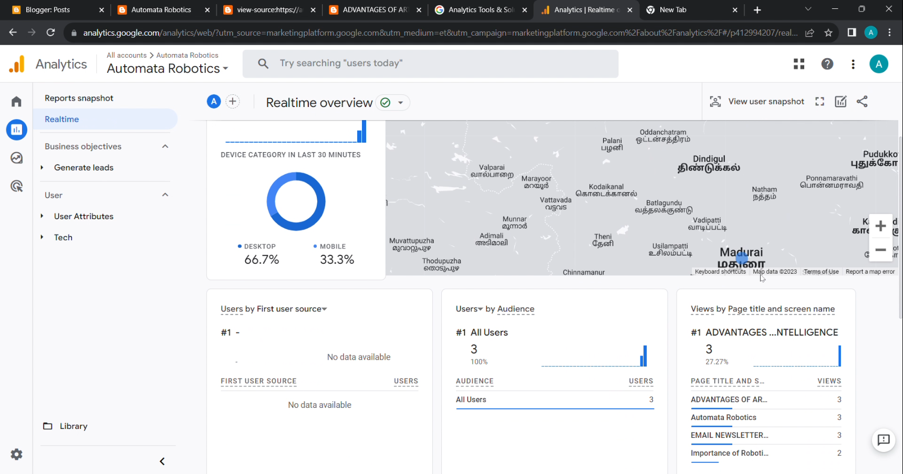

* It gives the details like the page engagement, page views, location of the users and so on .

